# Learning to Use the Burner

**Introduction**

A flame occurs when a "flammable" substance reaches its ignition temperature and burns. A flame represents a chemical change because the original substance that is being burned will be changed into something new. A flame results from a combustion reaction. Combustion reactions require oxygen, occur quickly, and produce lots of heat. A good source of heat has always been a requirement for many experiments. Robert Bunsen developed a new laboratory burner in 1853. The Bunsen Burner is now a standard piece of laboratory equipment. The burner allows a flammable gas (usually natural gas/methane) to be burned in a controlled manner. The Bunsen Burner was an important innovation in chemistry because it provided a convenient, safe source for a very hot flame. Up until that time, alcohol burners and candles had been used to provide heat. These sources provided inefficient, cooler flames. On occasion, we may choose to use a hotplate, which provides less intense heat, but does so without the danger associated with the open flame and the higher temperatures of a Bunsen Burner.

**Objective:**

* Learn the parts of a laboratory burner
* Learn how to safely use a laboratory burner
* Study the flames and their characteristics
* Light the burner with both a match and a flint lighter (striker)
* Time how long it takes to boil 50 mL of water

**Materials:**

Laboratory burner 100 mL beaker

Matches graduated cylinder

Flint lighter tap water

Beaker tongs

**Safety Precautions**:

* Always wear goggles
* Never eat or taste substances used in the lab
* Remember that hot glassware looks the same as cold glassware
* Boiling water and steam can burn skin

**Part 1: Learning the Parts of the Burner**

Obtain your burner and tubing and identify the gas inlet, air vent, burner tube, and rubber tubing. The apparatus comes apart into 3 separate parts: rubber tubing, burner tube, and base. Be sure the burner tube is secured. Check the tubing for cracks or wear. Call Mrs. A over if there are parts that are questionable.

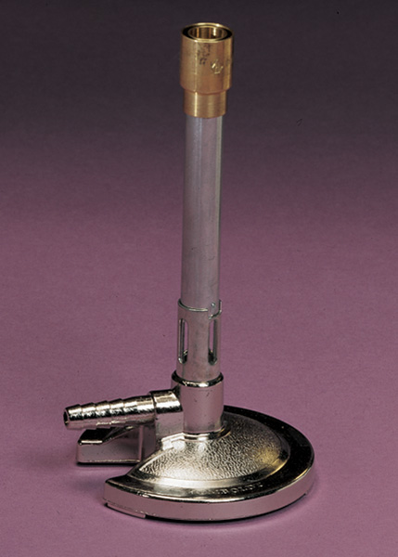

Tube

Air vent

Gas inlet

Base

Not shown: air adjustment, rubber tubing

**Part 2: Preparing the Burner for Lighting**

1. Connect the rubber tubing to one of the gas jets. Observe the pictures to determine if the jet is open (when the handle is parallel to the nozzle). Off is when the handle is turned perpendicular to the jet.

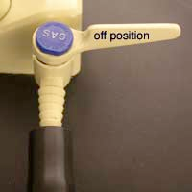

2. Obtain some matches. Make sure the burner is not positioned close to anyone or anything flammable. If you have long hair, make sure it is tied back. If you have loose clothing, such as a tie or a shirt that hangs at the elbows, take the necessary steps to ensure that the clothing will not get acquainted with the flame.

3. Adjust the air vent so that there is only a small slit visible at the base of the tube.

4. Decide which member of the lab team will be responsible for the match and which member will be responsible for controlling the gas supply. Light a match and place it just over the top edge of the tube. Your partner should now turn on the gas valve slowly to introduce the flammable natural gas. The gas should ignite and then you can adjust the level of gas vs. air to get the flame you want. You should turn the gas valve all the way on and adjust the gas flow at the jet itself. Burnt matches should be disposed of in the used chemical/burnt matches/ broken glass container at your lab bench.

5. If the gas blows out your match without igniting, immediately turn off the gas supply until you have a new match lit. If you leave the gas running while your partner is lighting the match then a flammable cloud of gas will form around your lab station and possibly cause an accident. Once the gas ignites, adjust the supply of air by rotating the collar at the base of the burner.

Repeat the process using a flint lighter instead of matches. One difference…turn on the gas, then make a spark with the flint lighter.

**Rule of thumb**: the gas valve should only be in the on position when

1. you have a lit match ready to start the burner flame
2. your burner is in operation and producing a controlled flame
3. you have the flint striker ready to use

**Note**: Sometimes a burner will "burn back". "Burn back" is when the gas ignites at the base of the burner and burns inside the barrel. The base and barrel of the burner will get hot. A properly functioning burner will not get hot except at the very top of the barrel. If burn back happens, turn off the gas, and inform the teacher.

6. If your flame goes out during an experiment, immediately turn off the gas supply, wave away the gas and light again.

**Rule of Thumb**: if you have tried three times unsuccessfully to light

The burner, wave away the gas, wait one minute,

then try again.

7. **Do not ever leave flames unattended**.

** Remember, the burner is NOT a toy and should be used appropriately. Inappropriate and unapproved materials should never be burned. Matches do NOT go into the sink. Let them cool on the base of the ring stand and then throw them into the used chemicals, burnt matches, broken glass container.

**Part 3: Adjusting the Flame**

Your burner flame can be adjusted two ways: gas and air

**Gas**: You should turn the gas jet all the way on (the handle should be in line with the gas outlet nozzle), and then adjust the gas flow at the gas jet.

**Air**: You can adjust how much air (oxygen) is feeding the flame by opening or closing the air control vent.

1. Adjust the air intake by screwing the tube closed (downward) and then opening the vent wide (upward). Observe what happens to the flame as it gets less and more oxygen.

2. Adjust your flame to be of medium height and have an "inner blue cone". Both members of your lab team should learn how to light and adjust the burner. See the picture for a good example of an inner blue cone. The wire is being held in the hottest part of the flame.

****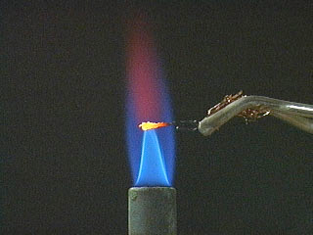

The burner flame burns at different temperatures in different parts of the flame as demonstrated in the picture above.